Week-3

Seller and Inventory Management System
Scenario:
The Seller and Inventory Management System is a database system used to manage seller details and product stock information. It helps an e-commerce company maintain seller records, product details and inventory information in an organized way. SQL commands are used to create tables, add constraints, insert records and generate reports.
- Create Seller Table
First, the Seller table is created to store the basic information of sellers. It contains Seller ID, Seller Name, Email, Phone Number and Address. The Seller ID is used to identify each seller uniquely.
Create Inventory Table
Next, the Inventory table is created to maintain product stock details. It contains Inventory ID, Product ID, Seller ID, Stock Quantity, Stock Status and Last Updated date. This table helps the company track the available stock of products.

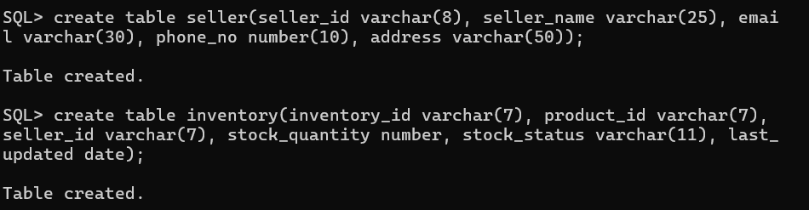

2.Establish Relationships
Seller and Product
A seller can supply many products.
A product can be supplied by one or more sellers.
Product and Inventory
Each product has inventory information.
The Inventory table stores and tracks the available stock of each product.

Primary key added for both tables
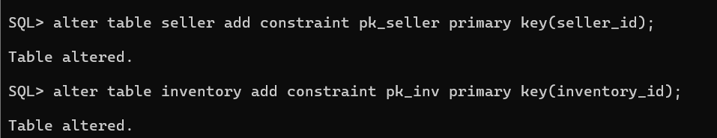
Foreign Key for Inventory Table:
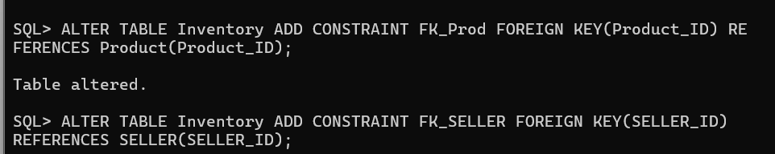
Constraints to make Unique Email ID:
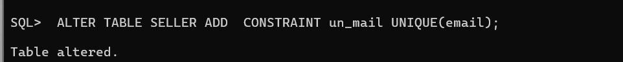
To make Email NOT NULL
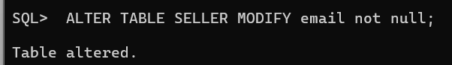
Add Constraint to Check the Stock Quantity is Positive
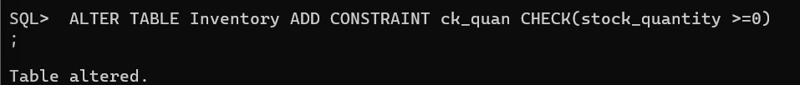

- Insert Seller Values
After creating the Seller table and adding the constraints, seller details are inserted into the table. The values include Seller ID, Seller Name, Email, Phone Number and Address. User input can be used to enter different seller records.
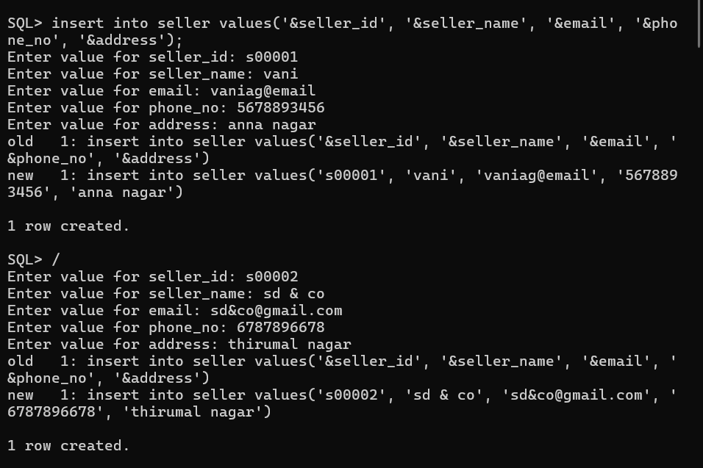
- Display Seller Records
The SELECT * FROM Seller command is used to display all the records from the Seller table. It helps to verify whether the seller details have been inserted correctly.
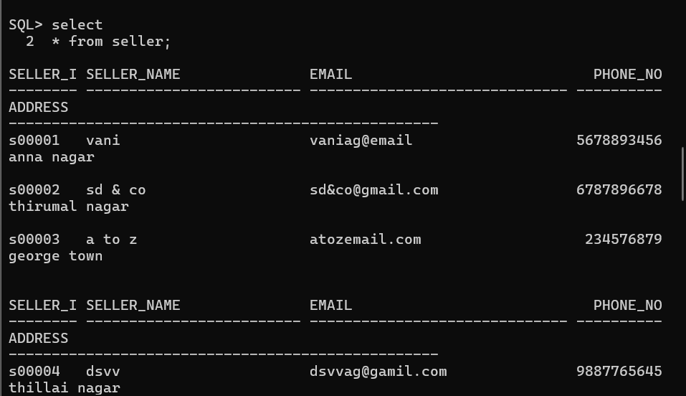
- Insert Inventory Values
Inventory records are then inserted into the Inventory table. The values include Inventory ID, Product ID, Seller ID, Stock Quantity, Stock Status and Last Updated date. The TO_DATE() function is used to store the date in the required format.

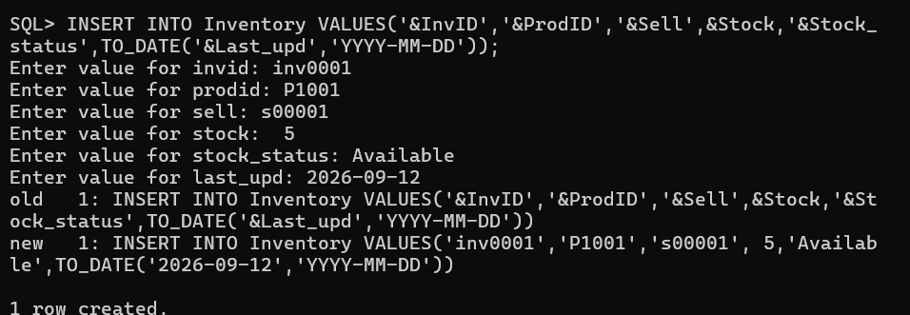

- Display Inventory Records
The SELECT * FROM Inventory command is used to display all inventory records. It helps to check the product stock and seller information stored in the database.

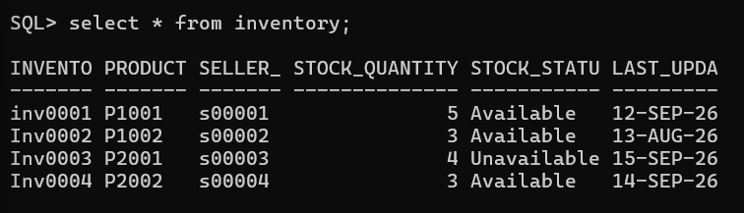

- Seller-wise Product Report

The first report displays information about each seller. It shows the seller name, number of products supplied and available stock. The JOIN operation is used to connect the Seller and Inventory tables. The COUNT() function counts the products and the SUM() function calculates the available stock.

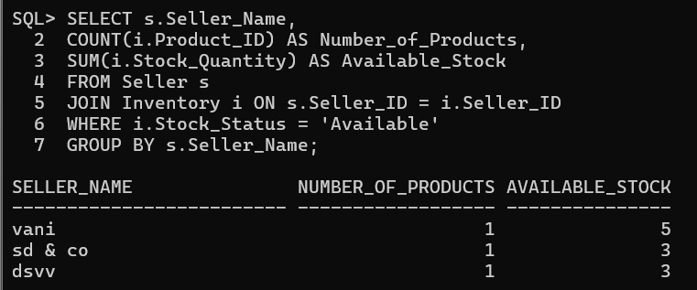

- Stock Availability Report

The second report displays the product name, stock quantity and stock status. The Product and Inventory tables are joined using the Product ID. This report helps the company understand the current stock condition of each product.

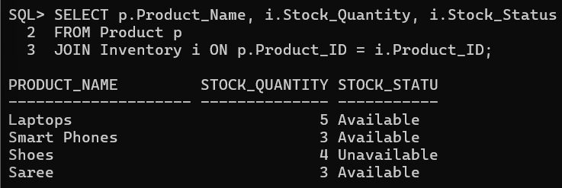

- Total Available Products

The next query calculates the total number of products that are currently available. The COUNT() function is used with the condition Stock_Status = 'Available'.

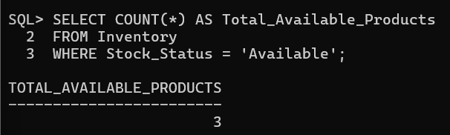

- Products Out of Stock

This query finds the number of products that are out of stock. It checks the inventory records where the stock status is Out of Stock.
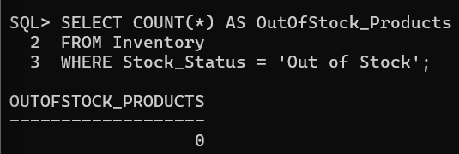

- Find Highest Stocked Product
This query identifies the product with the highest stock quantity. The MAX() function is used to find the maximum quantity available in the Inventory table. The Product and Inventory tables are joined to display the product name.

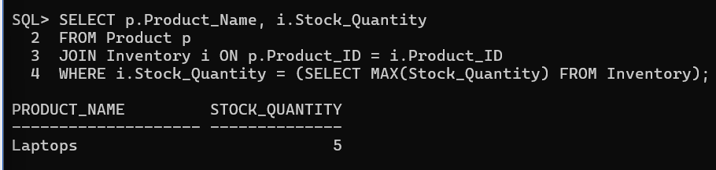

- Calculate Average Inventory
The final query calculates the average inventory quantity. The AVG() function

